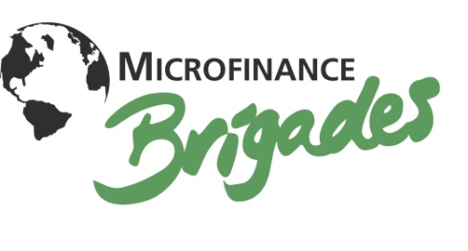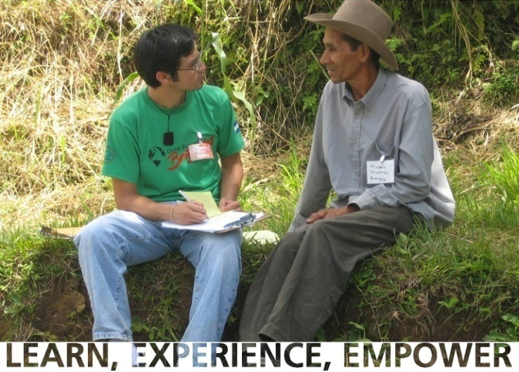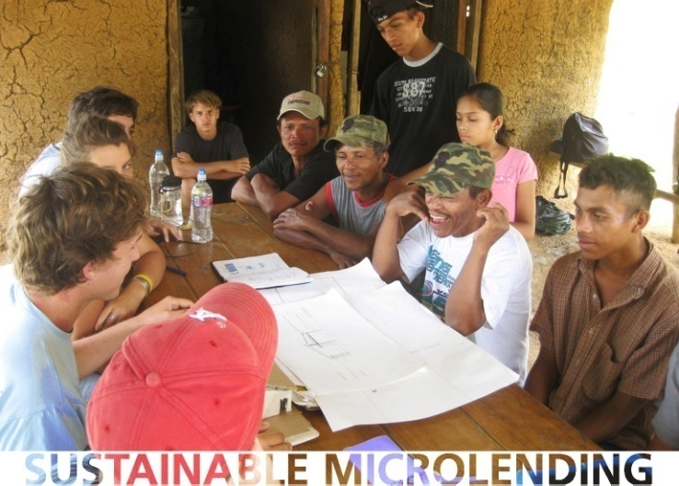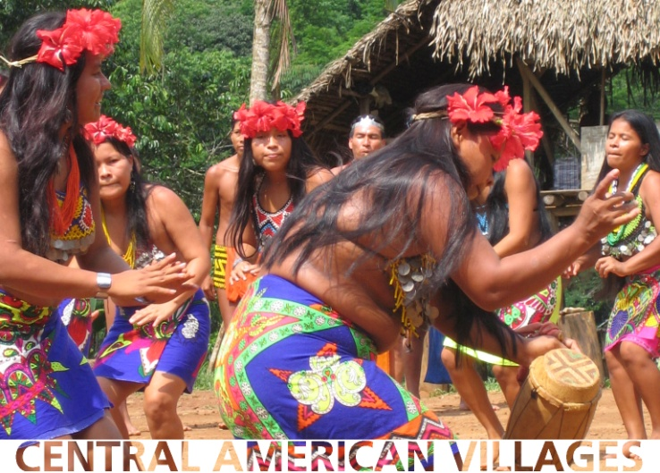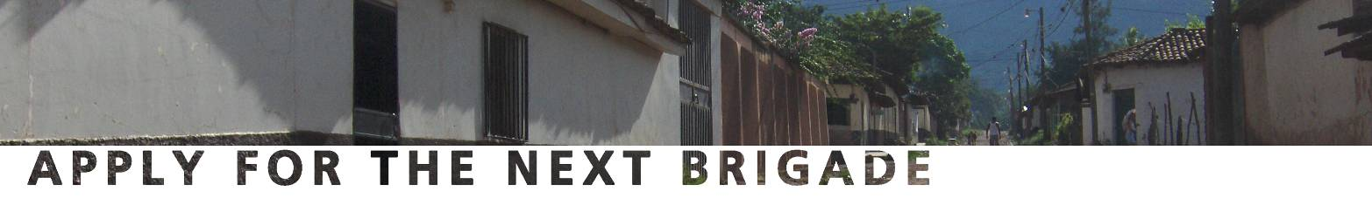

**Choose your brigade dates**

One week during Winter, Spring or Summer break to change your life!

**Honduras** is the current focus of Microfinance Brigades. The program directors develop local banks and identify borrowers in the same communities that Global Brigades’ health programs are being provided. Through this holistic approach to sustainable development, each community receives clean water projects, consistent medical and dental care, public health programs and access to micro lending.

**Important statistics about our micro lending partners:**

* Typical family income is less than $2 a day
* Average level of education is approximately 5th grade
* Limited to no access to microfinance
* Areas of high biodiversity at risk of environmental degradation

**A one week** **Microfinance Brigade** provides volunteers with the opportunity to gain first-hand micro lending experience and perpetuate the movement to alleviate poverty world-wide. Volunteers participate in real micro lending transactions and also engage in the daily lives of the actual borrowers. Learn about microfinance by participating in seminars from leading organizations, and by shadowing loan officers as they visit micro-entrepreneurs in their communities. Experience rural Honduran culture in welcoming communities, where few “outsiders” are invited. Empower community members to reach their potential with basic educational workshops and a capital investment that you personally deliver. Each volunteer is allotted $100 from their program fee to work with community micro-entrepreneurs and banks to determine how to allocate their loan.

working with the micro-entrepreneur.

**For more information**

[www.mfbrigades.org](http://www.mfbrigades.org)

**One week program fees**

**Honduras $750 USD**

* Meals
* Lodging
* In-country travel
* Educational seminars
* Brigade coordinators & translators
* $100 Capital Investment Fund

**Microfinance Brigades (MFB)** provides poverty-stricken communities in the developing world with the educational, financial, and organizational resources necessary to sustainably drive their own economic development.  MFB volunteers help the under resourced in remote villages build their own businesses, ensure against emergencies, and fund community projects.  By partnering with other international organizations in microfinance and agriculture, MFB provides the financial backing technical support to create and strengthen independent community banks. As mechanisms for social and economic change, these banks are then empowered to perpetuate other community projects facilitated by Global Brigades volunteers. This grass-roots approach advances communities away from dependence on outside aid and towards self-reliance.

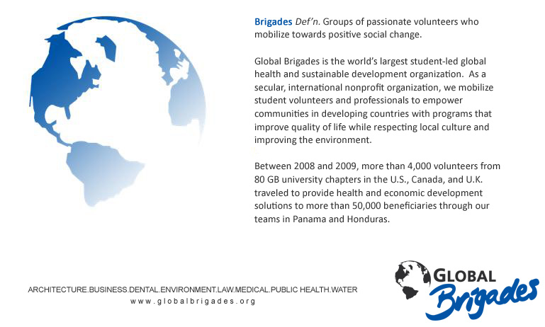

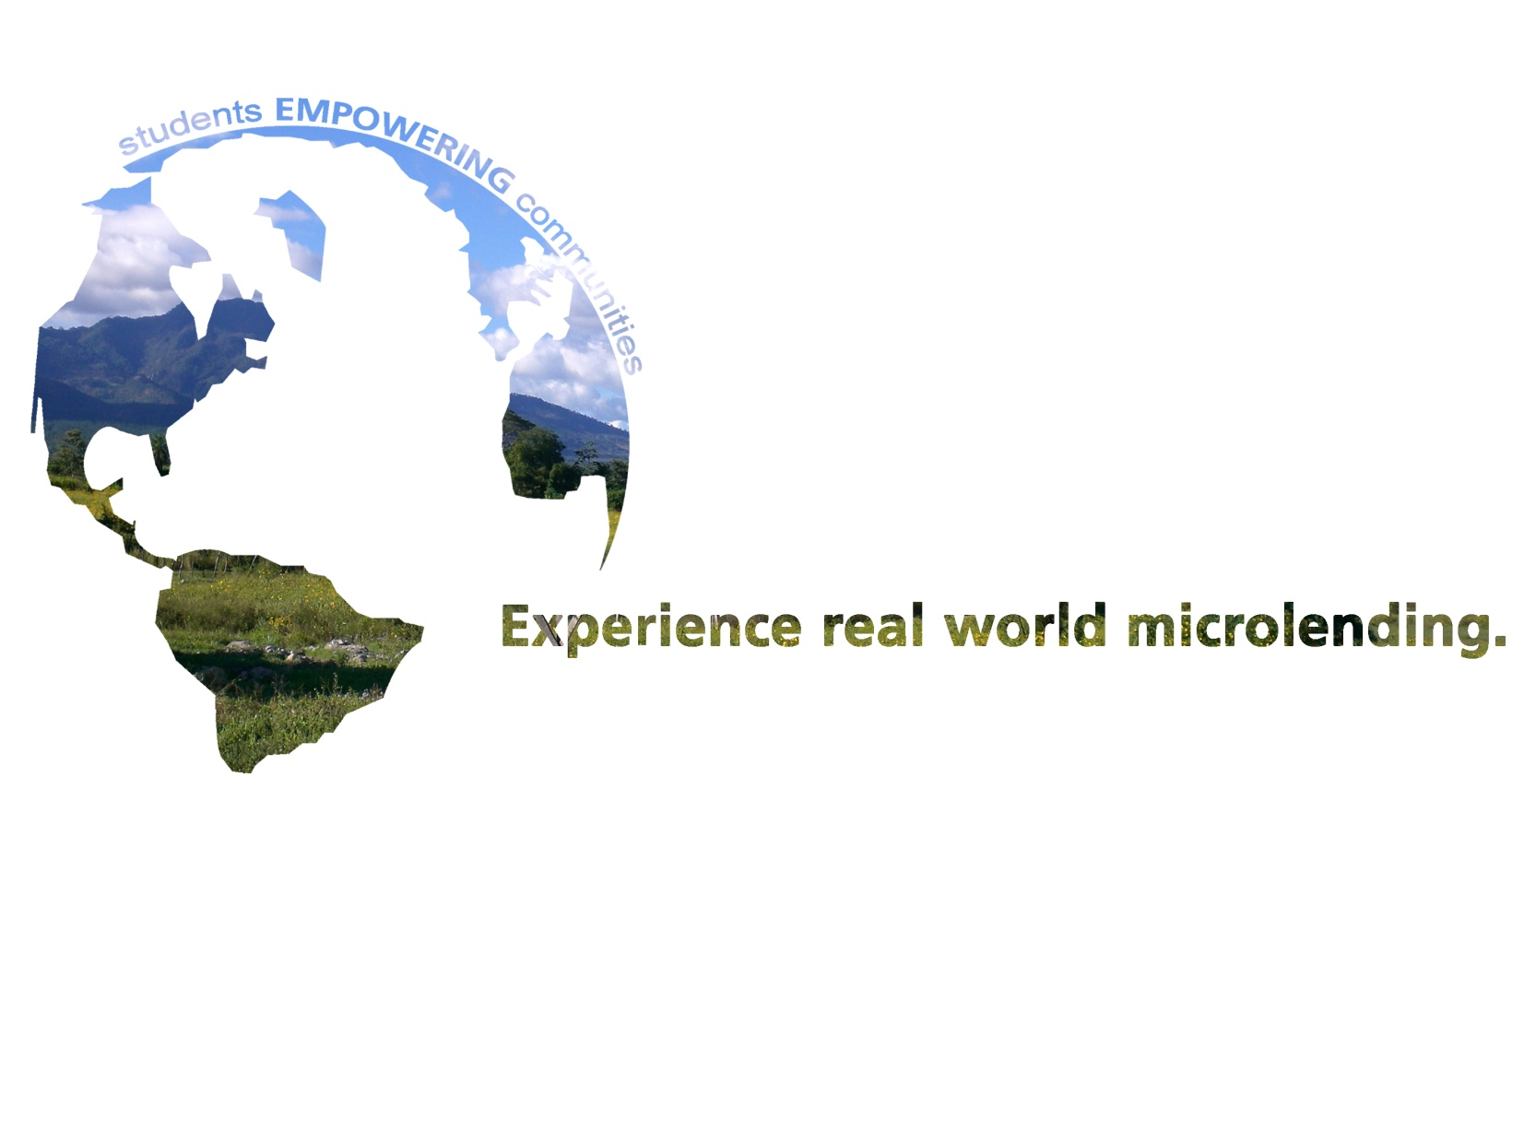

*Real loans that change the world.*